- Project Overview
In this project, we’ll walk through an end-to-end data project where we analyze Pizza Sales data using Microsoft Fabric, SQL, and Power BI.

🔹 Learn how to load and transform data in Microsoft Fabric
🔹 Write SQL queries to clean and prepare sales data
🔹 Build interactive dashboards in Power BI for insights
🔹 Track KPIs like total revenue, top-selling pizzas, peak sales hours & customer trends

We would like to visualize various aspects of our pizza sales data to gain insights and understand key trends. We have identified the following requirements for creating charts:
Total Pizzas Sold: The sum of the quantities of all pizzas sold.
Average Order Value: The average amount spent per order, calculated by dividing the total revenue by the total number of orders.
Total Orders: The total number of orders placed.
Average Pizzas Per Order: The average number of pizzas sold per order, calculated by dividing the total number of pizzas sold by the total number of orders.
Total Revenue: The sum of the total price of all pizza orders.

- Dataset Summary
  - Rows: 48620
  - Columns: 12
  - Key feature:
    - Pizza demographics ('pizza_size', 'pizza_category', 'pizza_ingredients', 'pizza_name')
    - Purchase details ('order_id', 'pizza_name_id', 'quantity', 'order_date', 'unit_price', 'total_price')
    - Shopping behavior ('quantity', 'order_date', 'order_time')
- Exploratory Data Analysis using python
  - Data loading: imported into dataset using pandas.
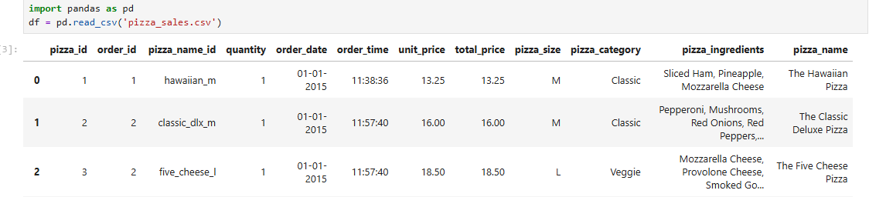
  - Initial Dataset: use .info() and .describe() for summary statics
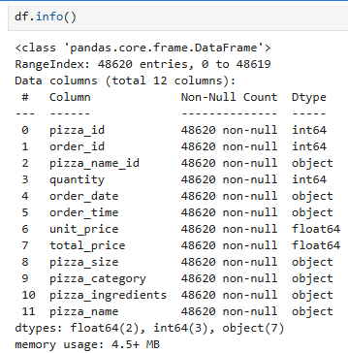
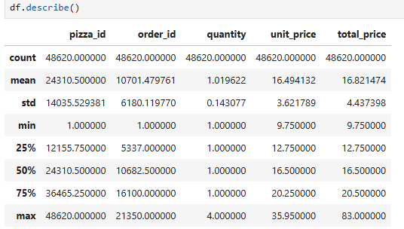
  - Column standardization:
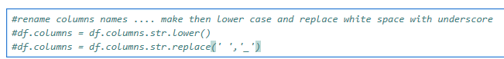
  - Data engineering:
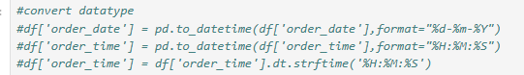
  - Data Integration: connected python script to PostgreSQL and loaded cleaned dataset into database for SQL analysis
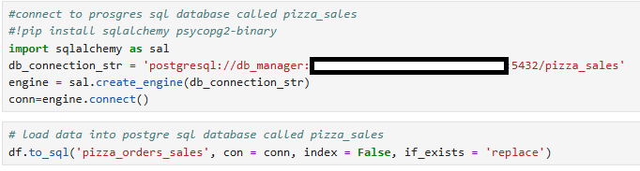
- Data Analysis using SQL: (Business Transactions)
  - KPIs
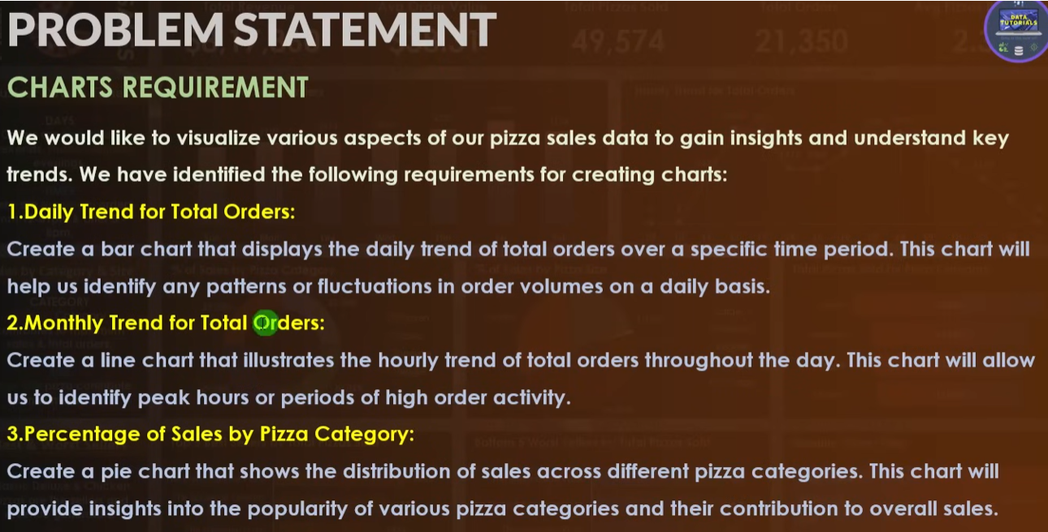
Daily Trend for Total Orders:
SELECT extract(isodow from order_date) - 1 as Order_Day, count(distinct(order_id)) as Total_Orders
FROM public.pizza_orders_sales
Group By extract(isodow from order_date) - 1

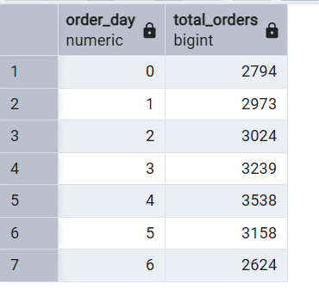
0 - Monday …. 7 - Sunday
Monthly Trend for Total Orders:
SELECT date_part('month', order_date) as Order_Month, count(distinct(order_id)) as Total_Orders
FROM public.pizza_orders_sales
Group By Order_Month
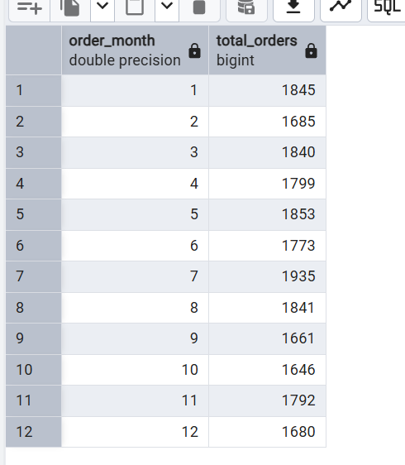

Percentage of sales by pizza category:
SELECT pizza_category , count(distinct(order_id)) as Total_Orders
FROM public.pizza_orders_sales
Group By pizza_category

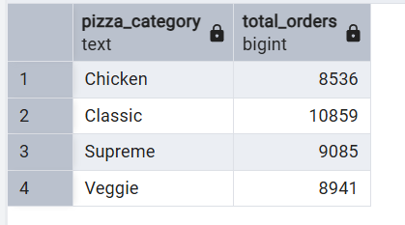

Get values for month of July (7)
SELECT pizza_category , sum(total_price) as Total_Sale, sum(total_price) * 100 / (SELECT sum(total_price) FROM public.pizza_orders_sales WHERE date_part('month', order_date) = 7) as PCT_Total_Sales
FROM public.pizza_orders_sales
WHERE date_part('month', order_date) = 7
Group By pizza_category

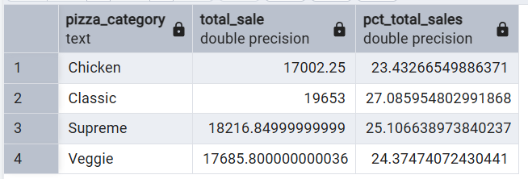

Percentage of sales by pizza size:
SELECT pizza_size , sum(total_price) as Total_Sale, sum(total_price) * 100 / (SELECT sum(total_price) FROM public.pizza_orders_sales WHERE date_part('month', order_date) = 7) as PCT_Total_Sales
FROM public.pizza_orders_sales
WHERE date_part('month', order_date) = 7
Group By pizza_size
Order by pizza_size

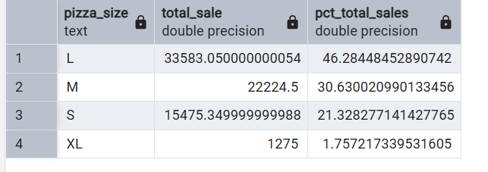

For moth of January
SELECT pizza_size , CAST(sum(total_price) AS DECIMAL(10,2)) as Total_Sale, CAST(sum(total_price) * 100 / (SELECT sum(total_price) FROM public.pizza_orders_sales WHERE date_part('month', order_date) = 1) AS DECIMAL(10,2)) as PCT_Total_Sales
FROM public.pizza_orders_sales
WHERE date_part('month', order_date) = 1
Group By pizza_size
Order by pizza_size

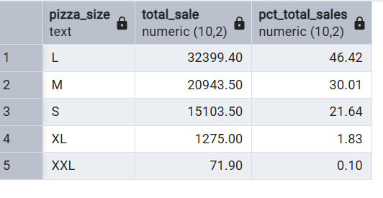
By first quarter
SELECT pizza_size , CAST(sum(total_price) AS DECIMAL(10,2)) as Total_Sale, CAST(sum(total_price) * 100 / (SELECT sum(total_price) FROM public.pizza_orders_sales WHERE EXTRACT(QUARTER FROM order_date) = 1) AS DECIMAL(10,2)) as PCT_Total_Sales
FROM public.pizza_orders_sales
WHERE EXTRACT(QUARTER FROM order_date) = 1
Group By pizza_size
Order by pizza_size

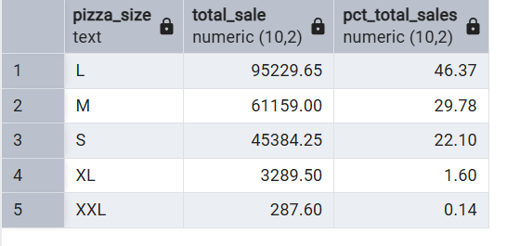

  - Data Sets of problem statement
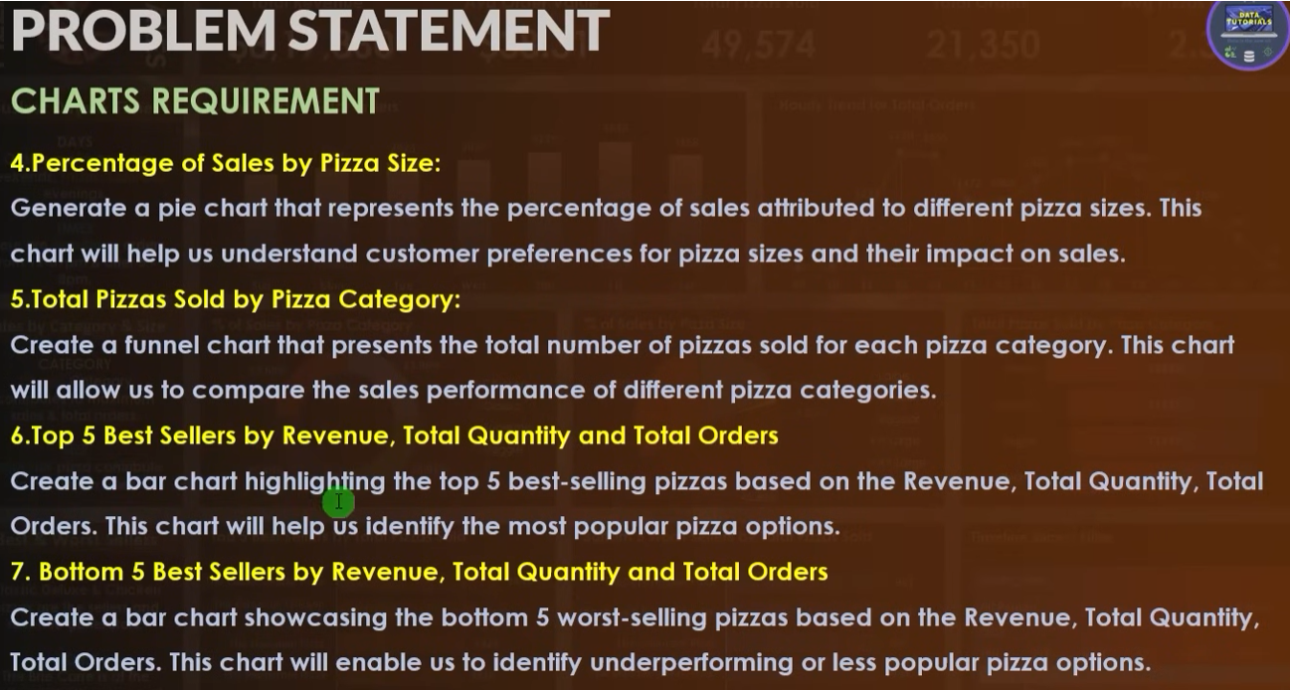

Total Pizzas sold by pizza name:

SELECT pizza_name, CAST(sum(total_price) AS DECIMAL(10,2)) as Total_Revenue
FROM public.pizza_orders_sales
-- WHERE EXTRACT(QUARTER FROM order_date) = 1
Group By pizza_name
Order By Total_Revenue DESC

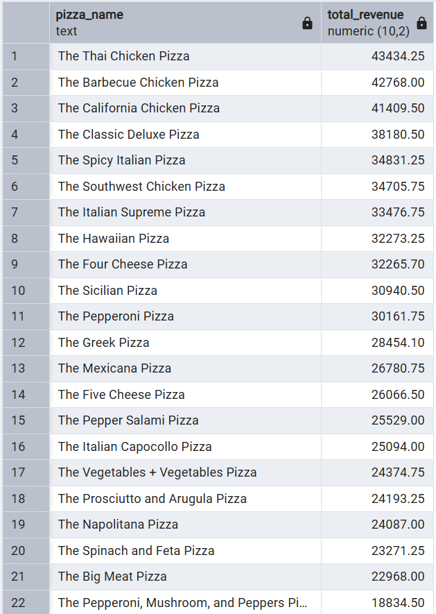

Total Pizzas sold by pizza Category:
SELECT pizza_category, CAST(sum(total_price) AS DECIMAL(10,2)) as Total_Sale
FROM public.pizza_orders_sales
-- WHERE EXTRACT(QUARTER FROM order_date) = 1
Group By pizza_category
Order By pizza_category

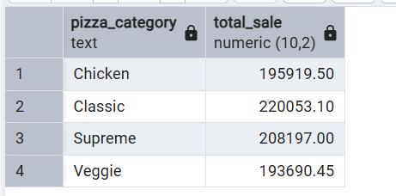

Top 5 best sellers by revenue, total quantity and total orders:

SELECT pizza_name, COUNT(DISTINCT(Order_id)) as total_orders, CAST(sum(total_price) AS DECIMAL(10,2)) as Total_Revenue
FROM public.pizza_orders_sales
-- WHERE EXTRACT(QUARTER FROM order_date) = 1
Group By pizza_name
Order By Total_Revenue DESC
LIMIT 5

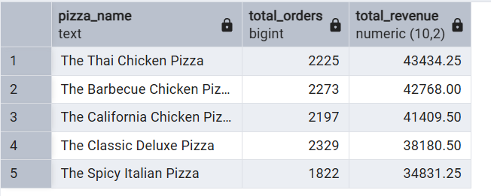

Bottom 5 worst sellers by revenue, total quantity and total orders:
SELECT pizza_name, COUNT(DISTINCT(Order_id)) as total_orders, CAST(sum(total_price) AS DECIMAL(10,2)) as Total_Revenue
FROM public.pizza_orders_sales
-- WHERE EXTRACT(QUARTER FROM order_date) = 1
Group By pizza_name
Order By Total_Revenue ASC
LIMIT 5

